Redirecting input/output in visual studio

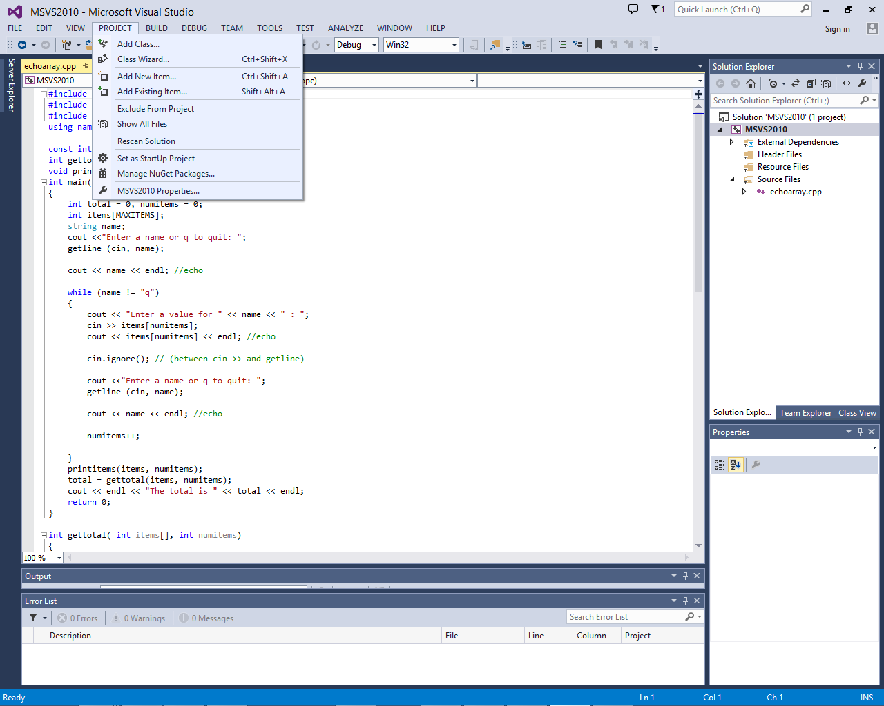Once you load your project and your .cpp file, click on “Project” and then “MSVS2010 Properties.”

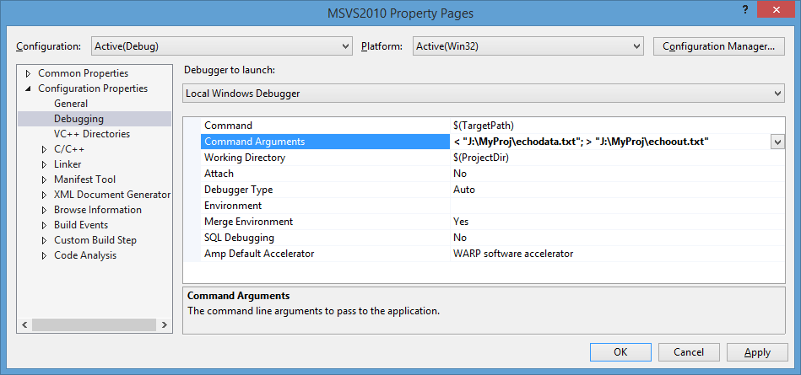Here you should see the property pages window. Select the “Debugging” option. In this option, there is a line for “Command Arguments.” It is here that you can redirect input to, and output from, the console. Below is a command that redirects a file (given in the path) into the console (with a “<”) and then redirects all of the output from the console (“>” outputs) to another file (located at "J:\MyProj\echoout.txt")

You can run the program like normal, but the console will just flash as if nothing happened. This is normal. However, you should see the output file created in the directory specified.

Here are the entries: (use your path)

Input Only: < "J:\MyProj\echodata.txt"

Output Only: > "J:\MyProj\echoout.txt"

I/O: < "J:\MyProj\echodata.txt";> "J:\MyProj\echoout.txt"